EXPERIMENT- 01

Title: To understand DDL and DML commands

**1. Create the tables**

**Table name: CLIENT_MASTER**

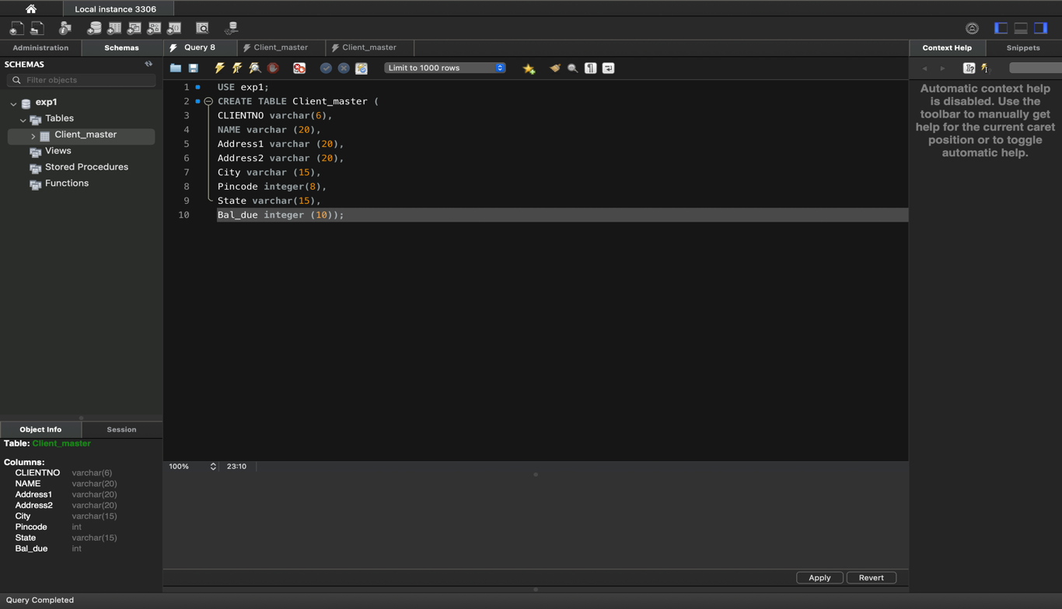

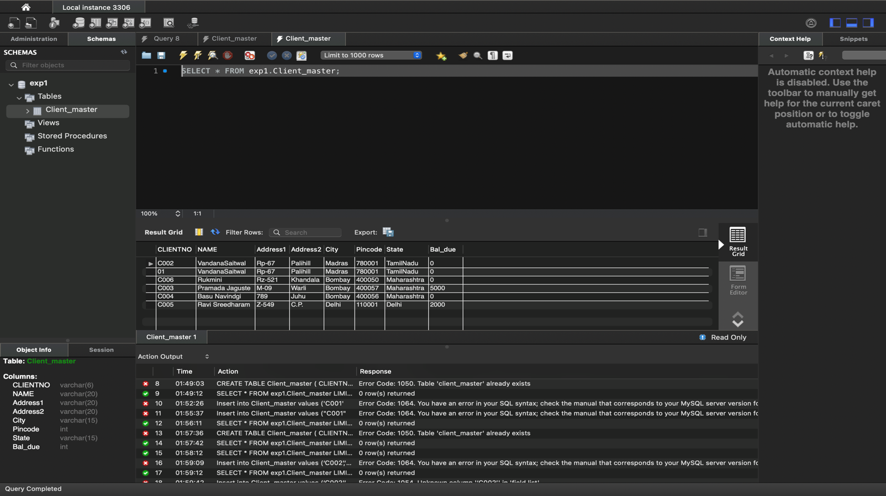

**Table Name: PRODUCT_MASTER**

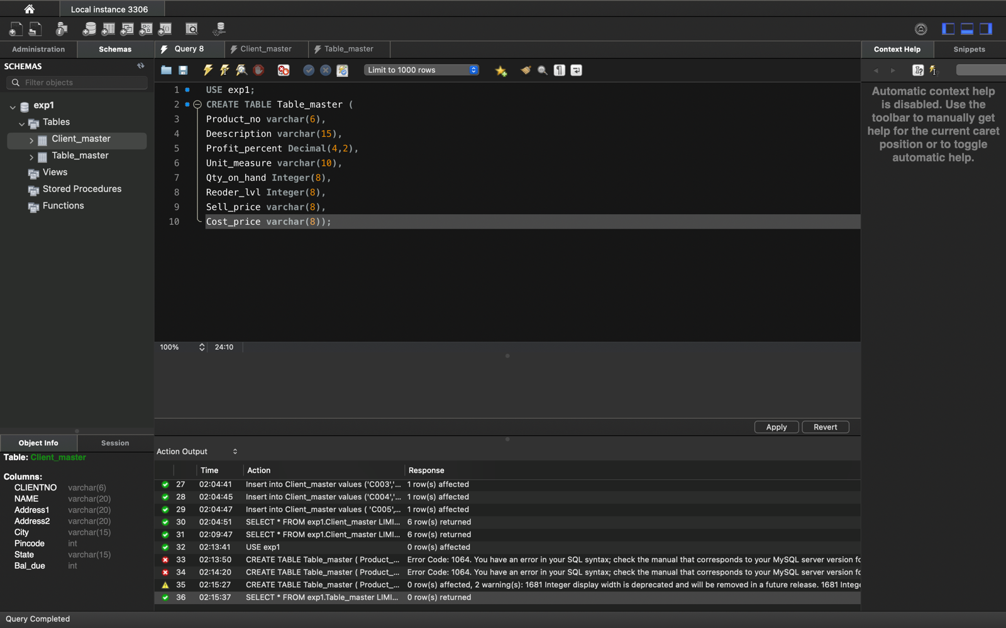

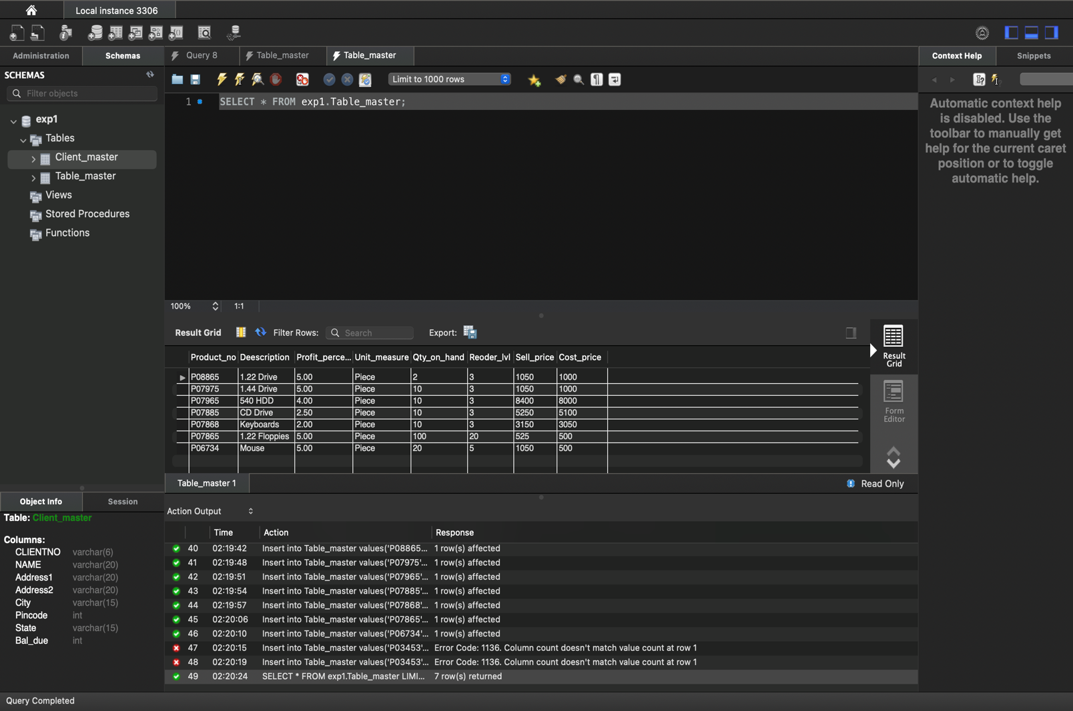

**Table Name: SALESMAN_MASTER**

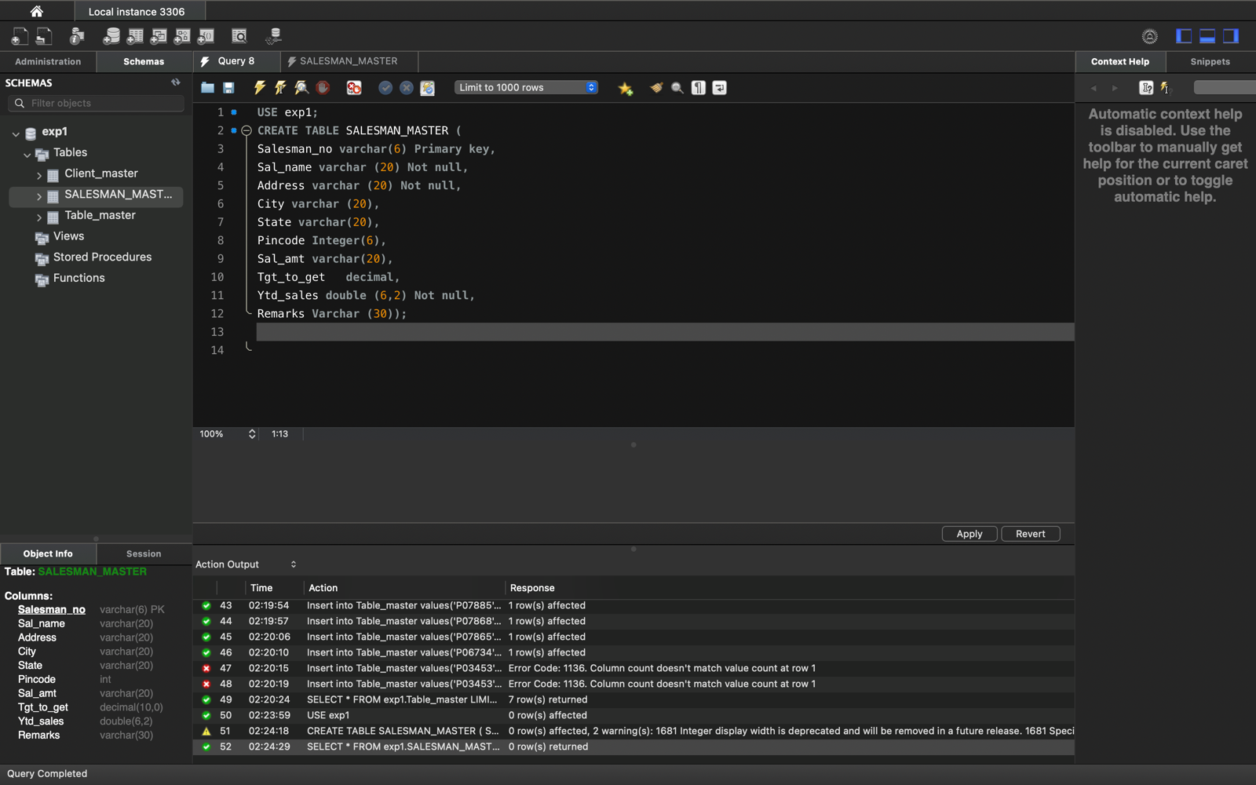

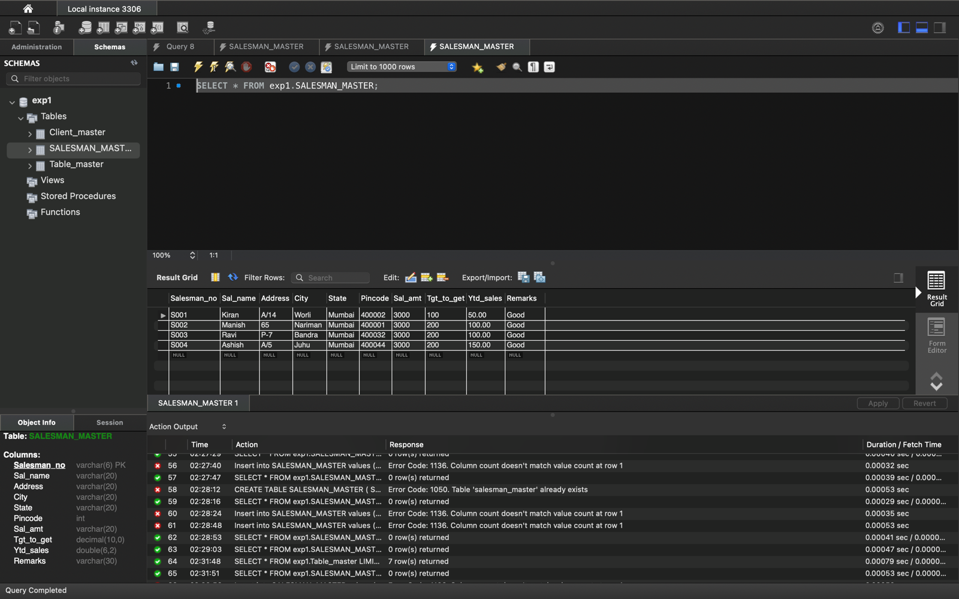

**2- Insert the data which is done above.**

**3- Exercise on retrieving records from a table**

* Find out the names of all the clients.

select name from client_master;

* Retrieve the list of names and cities of all the clients.

select client_no , name, city from client_master;

* List the various products available from the product_master table.

select product_no, description from product_master;

* List all the clients who are located in Bombay.

select client_no, name from client_master where city =’Bombay’;

* Display the information for client no 0001 and 0002.

select * from client_master where client_no in (0001,0002);

* Find the products with description as ‘1.44 drive’ and ‘1.22 Drive’.

select * from product_master where description in (‘1.44 Drive’,’1.22 Drive’) ;

* Find all the products whose sell price is greater then 5000.

select * from product_master where sell_price > 5000;

* Find the list of all clients who stay in in city ‘Bombay’ or city ‘Delhi’ or ‘Madras’.

select * from client_master where city in(‘Bombay’,’Delhi’,’Madras’);

* Find the product whose selling price is greater than 2000 and less than or equal to 5000.

select * from product_master where sell_price between 2000 and 5000;

* List the name, city and state of clients not in the state of ‘Maharashtra’.

select name, city, state from client_master where state=’Maharashtra’;

**4.** **Exercise on updating records in a table.**

* Change the city of ClientNo. ‘C00005’ to Bangalore’.

SQL> update Client_Master set city = 'Bangalore' where ClientNo ='C00005';1 row updated.

* Change the BalDue of ClientNo ‘C00001’ to Rs.1000.

SQL> update Client_Master set balDue= 1000 where clientNo ='C00001';1 row updated.

* Change the cost price of ‘Trousers’ to Rs.950.00.

SQL> update Product_master set costPrice = 950.00 where Description =' Trousers';1 rows updated.

* Change the city of the salesman to pune.

SQL> update SalesMan_Master set City = 'Pune';4 rows updated.

**5. Exercise on deleting records in a table**

* Delete all salesmen from the Salesman_Master whose salaries are equal to Rs. 3500.

SQL> delete from Amit where SalAmt =3500;1 row deleted.

* Delete all products from Product_Master where the quantity on hand is equal to 100.

SQL> delete from Product_Master where QtyOnHand =100;3

rows deleted.

* Delete from Client_Master where the column state holds the value ‘TamilNadu’.

SQL> delete from Client_Master where state ='TamilNadu';1 row deleted.

**6. Altering the Table Structure.**

* **Add a column called ‘Telephone’ of data type ‘number’ and size =’10’ to the**

Client_Master table.SQL> Alter table Client_Master add(Telephone number(10));Table altered.SQL> desc Client_Master

* **Change the size of SellPrice column in Product_Master to 10,2.**

SQL> alter table Product_master modify sellPrice number(10,2);Table altered.SQL> desc Product_Master;

**7. Deleting the table Structure along with the data.**

* **Destroy the table Client_Master along with its data.**

SQL> drop table Client_Master;Table dropped.

SQL> Select * from Client_Master;Select * from Client_Master*ERROR at line 1:ORA-00942: table or view does not exist

**8. Renaming the table.**

* **Change the name of the salesman_master table to sman_mast.**

SQL> Alter table SalesMan_Master rename to sman_mast;Table altered.

SQL> select * from SalesMan_master;select * from SalesMan_master*ERROR at line 1:ORA-00942: table or view does not existSQL> desc sman_mast;